PRESS RELEASE

LONDON Advertising ad campaign sees its awareness surge an impressive 50% and overtake Adam & Eve in Populus poll.

London – 12th August

In a Populus poll of awareness of UK ad agencies among over 2,000 members of the public, LONDON Advertising demonstrated the power of its ad TV and Outdoor campaign to promote its own brand with an outstanding set of results.

Lord Cooper, Founding Partner of Populus, said:

“Amongst the public, brand awareness of LONDON Advertising rose by an impressive 50% in just a month. LONDON Advertising is now 6 times more well-known than highly established agencies like VCCP. The increase in awareness of LONDON Advertising was the only statistically significant change in the month between our two polls, so their campaign clearly cut through. Among the critical sub-group of consumer opinion influencers, LONDON Advertising now has the highest awareness of any of the agencies covered in the poll, at 27% - its campaign taking it past Adam &Eve.”

LONDON Advertising launched a major national campaign between July 6th to 31st with 10 TV ads, starring Helen Mirren and Liam Neeson, on 9,000 spots on Sky TV and super-premium digital posters across the UK.

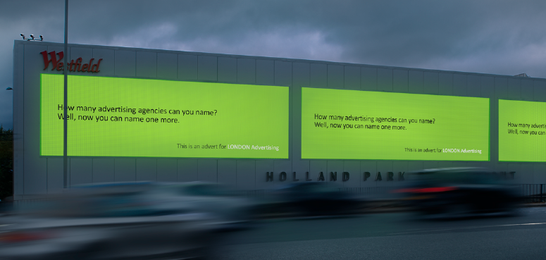

Michael Moszynski, Founder and CEO, said:
“Our objective was to generate a bit of fame for the agency and the poll demonstrates our campaign was hugely successful in delivering that. We also wanted to be talked about and with over 30 articles and interviews in national TV news, national and trade press we are now the agency on the industry’s – and public’s - lips. With a 3,000% increase in visitors to our website and one confirmed client win already, and several more in discussion with us, we trust our confidence in our own skills to promote our brand will show others that advertising, at least when we create it, pays.”

For further information contact: michael@LONDONadvertising.com +44 7968 063 155

Pre-campaign poll 3-5th July
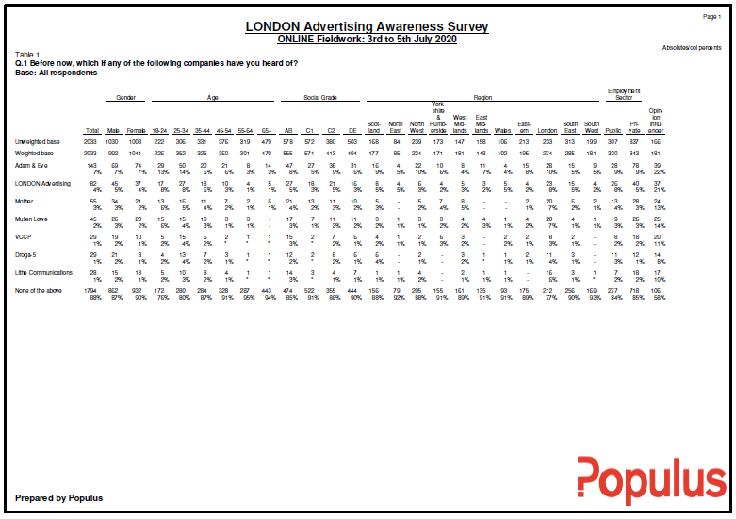

Post-campaign poll 5-6th August
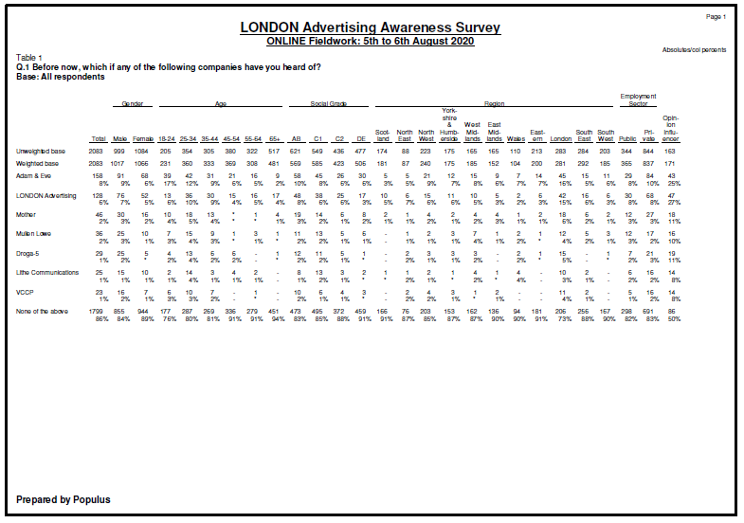

Notes for Picture/Website Editors

Videos of all 10 TV ads featuring Helen Mirren and Liam Neeson can be downloaded here
Hi-res image of the poster ads can be downloaded here

About LONDON Advertising

LONDON Advertising is a global agency with just one office. It was set up in 2008 (two weeks after the collapse of Lehman Brothers) to disrupt the traditional network agency model. Since then it has worked with clients based on every continent and run campaigns in more countries than WPP has offices. The agency’s iconic “I’m a fan” campaign for Hong Kong-based Mandarin Oriental has proven to achieve the highest ad recall ever recorded by Ipsos Mori.

LONDON Advertising has been voted Agency of the Year for six out of the last seven years.

The Agency bought and redeveloped its global HQ, LONDON House, winning the RIBA Award for the Best Office in the UK.

After the last downturn it funded a £100,000 prize to identify the best digital talent and got the Prime Minister to launch it. The agency incubated the winning idea and secured £4m in funding to make it the most funded tech start-up in Europe.

In September 2019, the Agency’s two Founders and owners sold the company to its staff in the form of an Employee Owned Trust.

